**Load Delivery Management System**

Financial and Technical Proposal

We will have entry and editing forms for below items definition: ($70 each of below item) – After Discounts $50/each

1. Brokers

2. Broker Helpers

3. Carriers

4. Carrier Helpers

5. Trucks

6. Zone/location

7. Country

8. State

9.Driver

Security Features (login, user’s management, roles management) - $400 – Discounted $300

Android and IOS App for Driver tracking.

**Other Screens**

**Home Screen with weekly, daily, monthly, yearly report: -- $200**

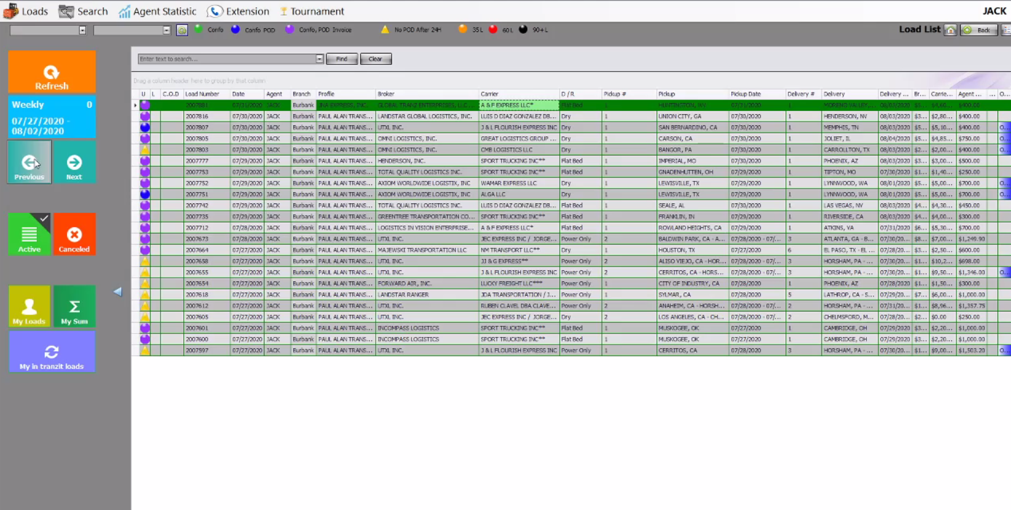

**Credit Check against Broker - $50**

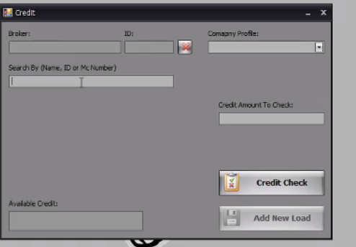

**New Load Screen (Broker and Carrier selection with their details) - $150**

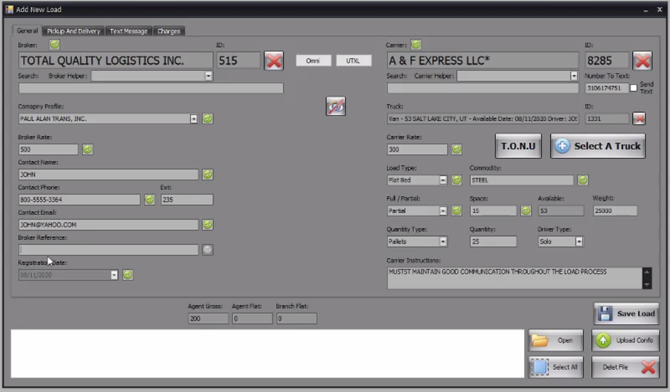

**Pick and Drop details with Confo document uploads -- $150**

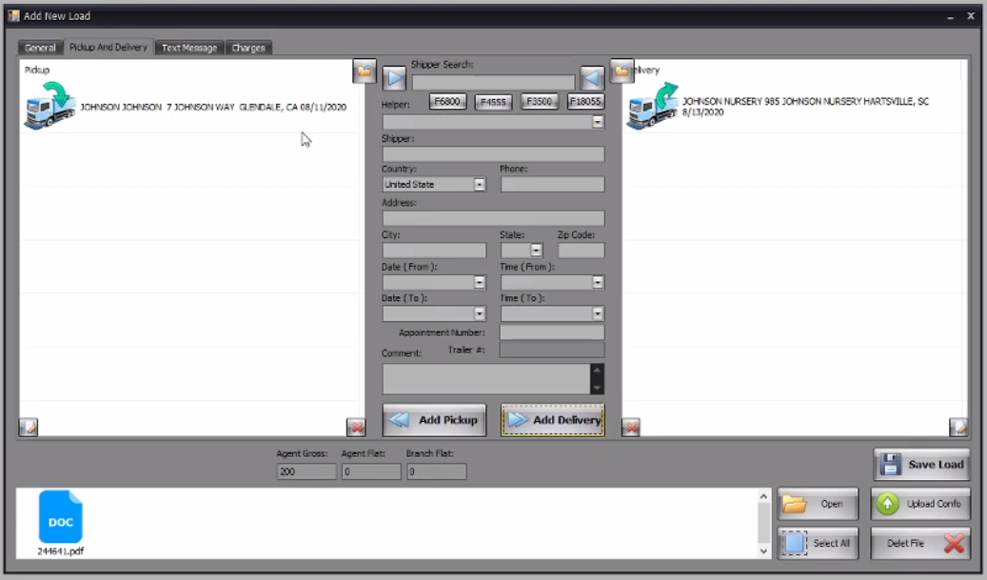

**Extra Charges or Deductions -- $100**

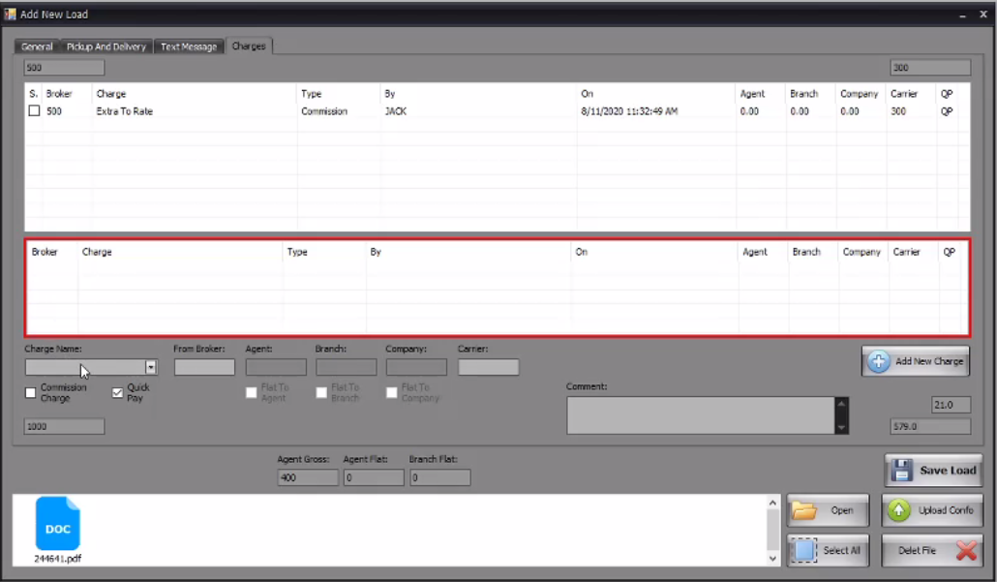

**Load Previous and Confirmation statuses Management -- $200**

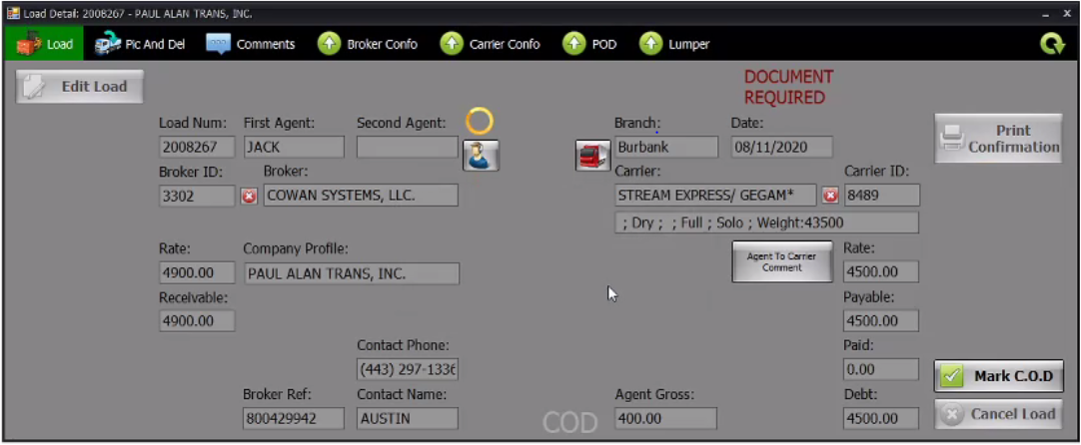

**Load document preview and export options --** **$150**

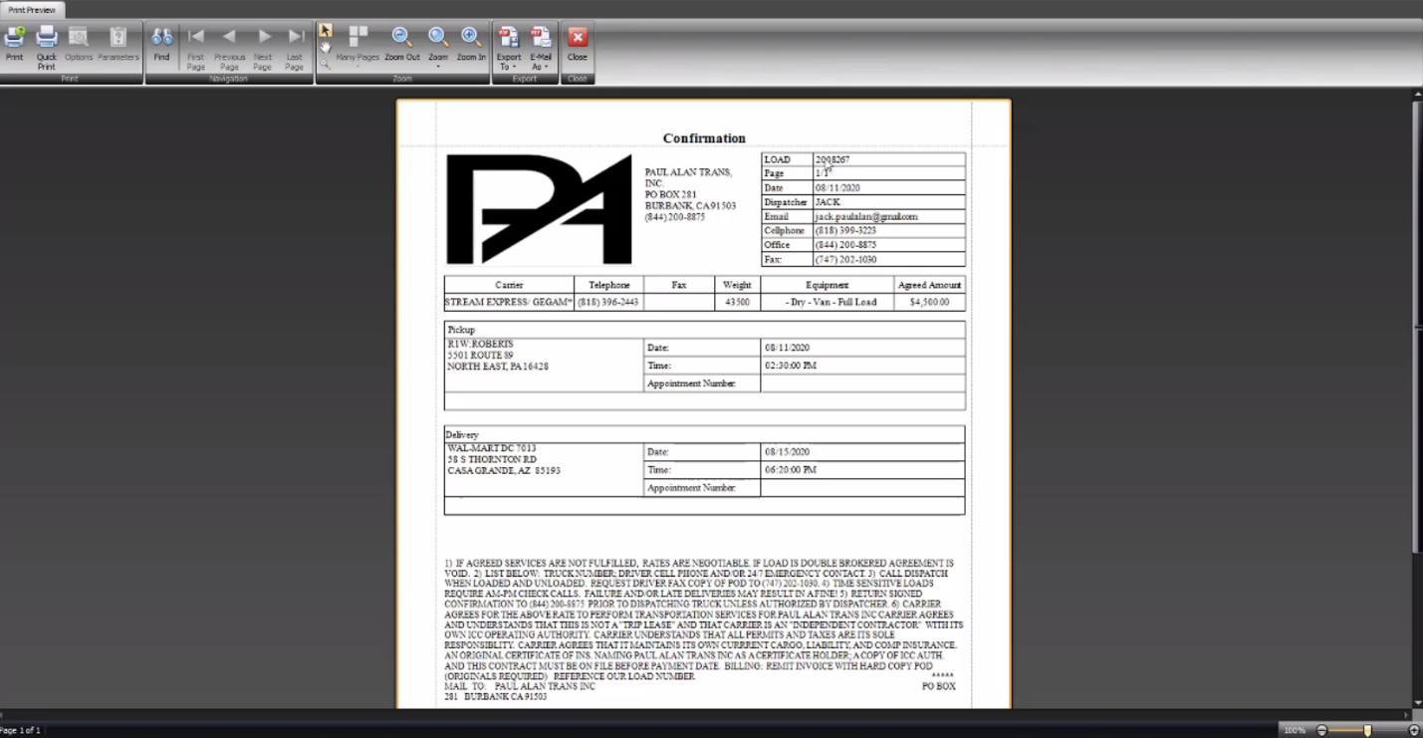

**Trucks and Drivers detail, Searches based on Zones, Drivers, Statuses, Carriers - $200**

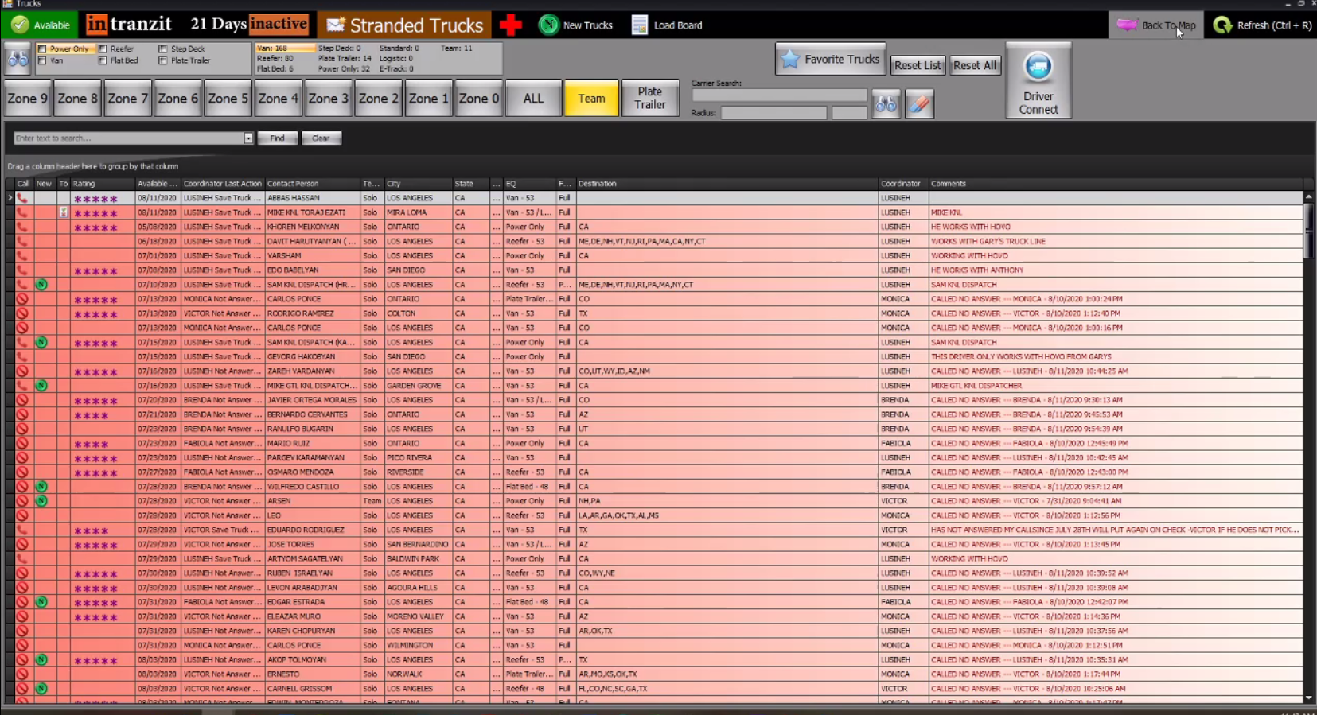

**Carriers and their truck details including driver’s info**

**Review/Feedback management based on their work -- $120**

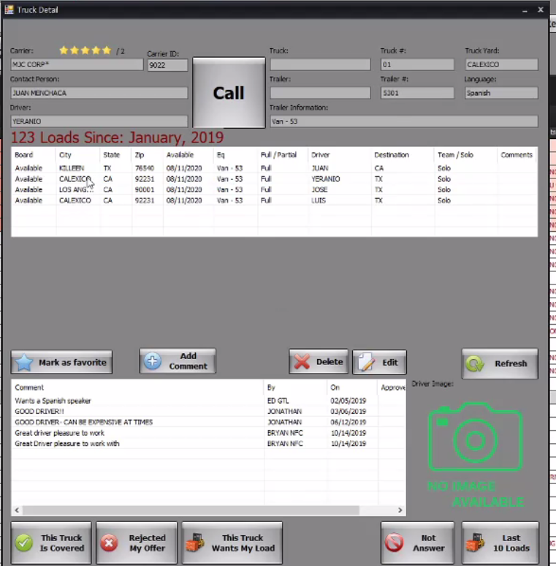

Financial Summary

**Estimated Efforts Cost:** $2020 USD (Windows Desktop Application)

**Development Timeline:** 6 Weeks

**Testing and Revisions:** 2 Weeks

**Free Maintenance Support:** 2 Weeks

**Users Limit:** unlimited

**Team:** 1 Desktop Application Developer, 1 Database Developer, 1 QA

**Terms & conditions:**

1. On deployment of the project the order should be closed.
2. Any additional features / modifications will subject to new contract.
3. After 2 weeks of free maintenance, charges will be applied as $20/hour.
4. Any other hardware, any other development, is not included in the cost.
5. For making the database live hosting or live server cost will be charged separately as per providers’ cost

**Suggestions:**

Why you do not, we go for Web application?

It will be accessible from any device, without any installation on specific system.

Web application is more flexible than Desktop application in terms of design, features and accessibility etc.